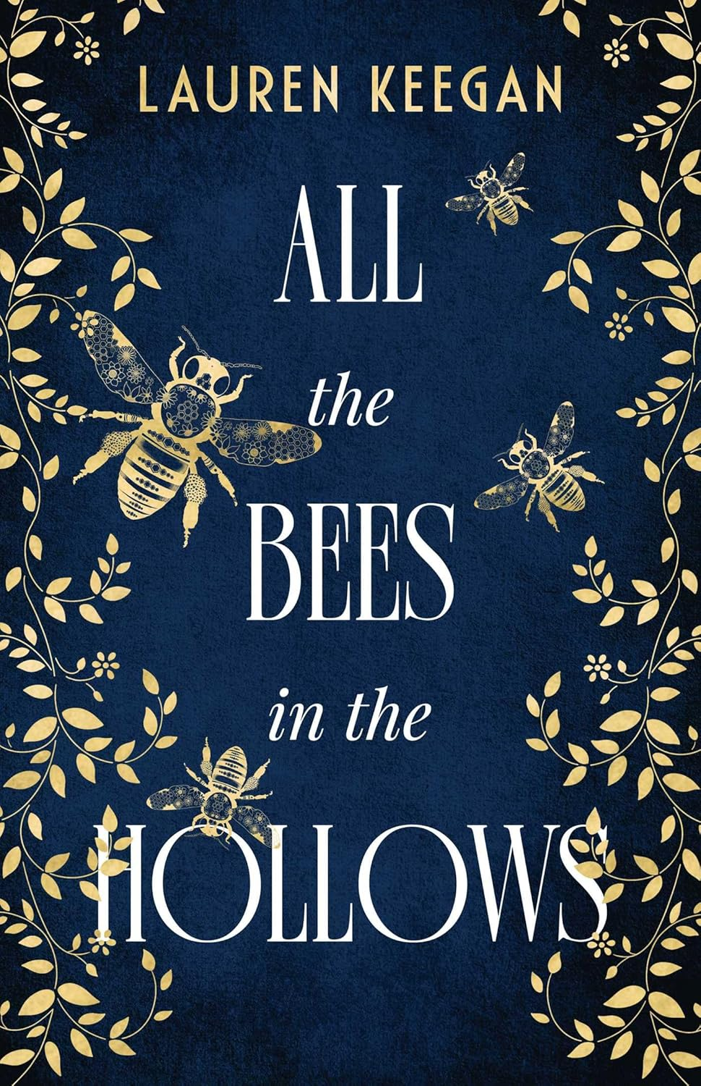

All the Bees in the Hollows
Lauren Keegan
ISBN: 9781923022850
Category: Fiction, Historical,
Themes: Community, Church, Beekeeper, Bees, Relationships, Grief, Death, Nature, Culture, Trees, Generations, Folklore, Faith
Date Read: December 2024
Rating: ♥ ♥ ♥
My Book Notes:
The trees fall silent but my heart raps like a tree hollow being chiselled out by a woodpecker.
* * * * * * *
In the silence a cuckoo call echoes. Hoo Woo. Hoo Woo. Hoo Woo.
And the vibrations shatter my body. I squeeze my eyes shut. And then my chest expands, and the forest breathes once more. I slip, no longer held by the sturdy oak torso but shaken off at the foot. My legs are tingly and unsteady as I draw myself up. Home. I must get back, to the cottage, and my family, and the bed. I had been so desperate to escape the den but now my chest aches for nothing more than my family pack. Before it is too late.
* * * * * * *
Senele's (grandmother) voice grows weary, and the words cease. She rocks back and forth, her arms around her torso. We stand together around Tévas's (father) bed and yet I feel lonelier than ever. She looks to me, but I can't find voice or the words, and so silence descends. Shame too. I was not here when my father left, and I am not strong enough to carry the ancient traditions.
* * * * * * *
Marytè (mother) was in no mood to argue with her daughter, and besides there was no time. It is her duty as a beekeeper to extend the news of Baltrus's death to their bee family. Austeja (daughter) knows of the consequence if Marytè fails in this: if she does not awaken the bees, they will fly away with Baltrus to heaven. Or worse, they will die of heart break, Senelè would say. And what will happen to her daughters then?
* * * * * * *
Like the bees in a hive, the families in the settlement work together, respect each other and put the needs of the community before their own.
* * * * * * *
Maryte’s blood pulses through her body, the familiar rush of scaling a tree, rising above the forest, the same as men. It is almost as intoxicating as Baltrus's honey mead. Thinking of Baltrus and his mead-making reminds her of another responsibility she will inherit. Honey, wax and mead are how they paid their taxes, and if they don't pay their taxes, they will lose their right to tree beekeeping. They will lose their livelihood, not to mention their traditions.
* * * * * * *
Worry. That is the emotion etched on Motina’s face: the creases are deeper now that she sits beside my sister. Did she see something in the forest? Will spring come soon, or not soon enough? I hope the bees do not take flight as we put my father to rest.
* * * * * * *
How can I explain to Senelè what I felt when I do not understand it myself? Senelè clings to the old ways, but it is discouraged. Our family is Christian, and we must hold on to our faith, especially now.
* * * * * * *
What will I do without Tévas? He is the only person who doesn't ask me to be someone else. The only person who sees me. Saw me.
A sob escapes and my body shudders. I did not think there were any more tears left to shed. But, just like spring, the drying of the well is holding off a bit longer.
* * * * * * *
‘Here, let me help.’ Jonas moves quickly before I can protest and one sturdy arm links beneath mine and I am up on my feet again. He steps back, catches my eye and then glances away. His cheeks are flushed. He must have walked here on his own. 'My Motina asked me to come and offer my help. Your Motina asked me to collect some firewood from the barn.'
* * * * * * *
To care about those outside her family, her bees and the community is too much weight to bear. Grief has already settled upon her shoulders.
* * * * * * *
She will find peace with her loss by continuing with her duties. She hopes it will help her daughters heal too: she sent them out upon the priest's arrival. Keeping her daughters busy and going about their usual duties will help the long days without Baltrus pass more easily. It may seem like punishment, but she only wants to help them.
* * * * * * *
She leans against the doorframe, waiting. Waiting, A buzzing within her chest, rattling around, waiting to soar. She imagines the bees feel restless too, impatient for the weather to be just right, the temperature warm enough to leave behind the safety of their winter cocoon. In winter the bees hibernate but so too does Maryte's soul.
* * * * * * *
Uncertainty. It always unsettles her. Her entire life is guided by the seasons of a beekeeper. The structure is containing, but the changeable timeframe is not. She knows spring will come, her husband will be buried, and the honey will be harvested, but when exactly is not within her control. It is in the hands of everything around her: The forest, the sky and the earth. Deities. God.
* * * * * * *
Though she often finds solace in the church, today she is relieved to no longer be indoors. The ecclesial room inside mimics the forest; its pillars and columns simulate the tree trunks of the pines that surround the building.
* * * * * * *
I can see why my mother adores this community so much. I've often felt stifled by the smallness of it, but for Motina, it is security. Even with all the rules and regulations- such as a young woman being in the presence of a man, or men, alone - common sense prevails, and they do what needs to be done.
* * * * * * *
Marytè has certainly never been afraid of the quiet and she's always been more at ease in her own company than those of others. Though the grief of her lost babies is a burden on her heart, she is not quite sure how she’d have coped with a house full of rambunctious children like her mother had. Perhaps that's why she was drawn to her father's placid temperament and his work with the bees. It took her away from the busy house and her siblings.
* * * * * * *
Marytè's chest tightens. It is in these moments she does not know what to say to take away her daughters' pain, when she too feels the pain so deeply within herself. She also misses Baltrus. She misses how he’d bring laughter and ease to their home. Without him it is sombre and tense.
* * * * * * *
It was Baltrus who encouraged her to focus on their important role and to not be caught up in what they could not control. They left behind their own families because this was an opportunity to start afresh. Together they continued doing what they loved, even if it meant honey became barter for taxes - though she had never been able to let go of her resentment. The forest should belong to no one.
* * * * * * *
It should no longer surprise me how life can change in an instant. When my brother passed last winter, I felt then for the first time in life a deep sense of loss. Azuolas was more reserved than Tévas, but his absence was like the gaping hole left by an uprooted tree: at surface level it is concealed but the damage is palpable when you peer a little closer. Now with Tévas gone, it's as if every pine in the forest has been wrenched from the earth and tumbled aside. It's as if there's a big gaping hole in my gut that will never be filled.
* * * * * * *
Tévas was always like the bridge over the river, keeping us connected even when it felt like we were flowing in different directions. Without his light, everything feels dark and heavy. Motina is distant and preoccupied. She's standing with Elena and Aldona but her fixed smile never reaches her eyes. Two deaths and someone tampering with the hollows have troubled her.
* * * * * * *
She breathes in the floral scent and for the first time since Baltrus left, the tension eases. It is here she sinks into the tender earth. It is here tears spring to life and trickle down her cheeks. Tears of sadness and joy.
* * * * * * *
Mothering her children is fraught with complications. There are feelings and personalities to consider. She never seems to get it right. She loves her daughters, with all her heart, but at times she does not know if it is reciprocated. Or whether she deserves their love. With bees there is no guesswork. They are wonderfully predictable and loyal.
* * * * * * *
Her children look to her for guidance - even now - in ways beyond her capabilities. She can teach them to sow, to bake bread, to climb a tree, but when their eyes are trained on her with uncertainty about the bigger things in life, such as meaning and religion and grief, Marytè is lost. When they come to her with these emotions, these questions, she feels herself close off. She has never been taught herself. She had no guidance after her father's death and so learned to rely only upon herself, and later, Baltrus.
* * * * * * *
I too have experienced this. For many years after I lost my Ignas, my only son to survive birth, he was with us through two seasons, but afterwards, I would see him in the clearing. Not far from where you stood with Liudvikas. Running around collecting insects, living the life I’d hoped he would one day have. Aldona sighs. 'But it was not meant to be. There is nothing pathetic about grieving those we love.’
* * * * * * *
It is strange how this forest can protect us from threats but simultaneously keep us naive about what is happening beyond the treetops. My rare trips to Alytus or Kaunas as a child were like visiting another country. The city generated curiosity and excitement. As a child, who did not feel a calling in beekeeping, I had been enticed by the sights the smells and the sounds of the modern people of society. I had been biding my time ever since to escape to Alytus, away from the peasant life, away from the monotony of forest life.
* * * * * * *
I can't help but carry my mother's worry within me. My stomach stirs. How will we make it through winter with only half of our supplies? If our crops are damaged or there is no meat to eat, we always have our honey. But without honey, we have nothing.
* * * * * * *
The bees are loud today. They are in love with the warm weather and the abundance of flowers in the forest. She knows it will not be long now. There has been a repetitive, irregular sound coming from some of the hollows in the past few days. Bee hollows are busy...
* * * * * * *
I want to go home. Not to the cottage, but to the oak. To sit on my log chair. I know when I am wed, I will not be able to drift about the forest as I do now. I will have home duties and beekeeping tasks too. I will live in the same home, with my family, but life will be different.
* * * * * * *
She recalls feeling this way after her father's death upon the first harvest. Grief and sadness and yearning, but also eagerness to distance herself from these feelings and focus on collecting honey. There is something deeply satisfying in bringing in a harvest on her own. Being self-reliant.
* * * * * * *
Failure. That's how she feels. She failed her family and failed her bees. She only lasted a few months after losing her husband before her body fell apart and her mind plunged into dark thoughts she so desperately tried to avoid. The mead provokes them, yanks them out of the depths of her mind and parades them around in front of her in her rare waking hours.
* * * * * * *
I had no idea that it had become this bad. Was it only a few days ago we were bathing in the stream? And in that short time my mother has lost her mind, bathing in honey. I knew she'd taken the injury hard, but I thought the mead was helping her rest. Recover. Instead, she has unravelled and bears no resemblance to my beloved stoic Motina.
* * * * * * *
‘I will continue to pray for your mother, for her to heal,' Margusz (priest) says. He stands beside me, watching her. ‘To heal in both body and mind.’
* * * * * * *
No more time for self-pity. She will not let her daughters down. She will not abandon them the way her own mother did her. She could not do that to them, or to herself. She knows she committed a sin, and she will repent. She plans to confess to the priest - he probably already knows but she will tell him anyway - and she will do what it takes to get back on the righteous path. To become the mother her daughters deserve and a beekeeper deserving of bees.
* * * * * * *
It was suppressed fear, buried secrets stomped down into the depths of her soul along with any painful emotions she ever experienced, the ones she doesn't like to acknowledge or feel. One little trickle dropping upon another, until her body was flooded with so much pain, regret and hurt that there was nowhere else to hide. It seeped out of every crack and crevice.
* * * * * * *
Death, loss, abandonment, change. An interwoven pattern that snakes throughout her life. It has kept her wound up, it has kept her at a distance from the people she loves, it made her push them away when she wanted to pull them closer, hold on tight.
She's made a mess of it all.
* * * * * * *
The learning and growing never stops. And with each ripple in the stream, each new direction, she is carried along, whether she likes it or not. Austija has proven she has what it takes to keep her head above the water when life takes a new direction. And Marytè will prove to her daughter she can do it too.
There's balance in the forest again. I can feel the change as I walk along the forest path. Negative energies are drawn out and cast aside. It is not exactly peace, but there's comfort in truths being unearthed and the seeds of hope scattered among the pines.
* * * * * * *
Senelè gave me the gift of trusting my instincts, leaning into my connection with the forest and, most importantly, trusting myself. I will hold her wisdom within me; it'll strengthen my bones, direct the blood flow through my body, sharpen my senses. I will keep hold of the old ways, so they don't fade as Senelè feared. I owe her this.
* * * * * * *
In time, we will be able to look towards the future, instead of the past. Because in the past lies hurt and pain. The future is tantalisingly hopeful.
* * * * * * *
To survive, we must let go of some of our ways, to protect our family from threats. I'm sorry, Senelè, but we must let the eternal flame go out. I will relinquish the practice but not the memories.
* * * * * * *

