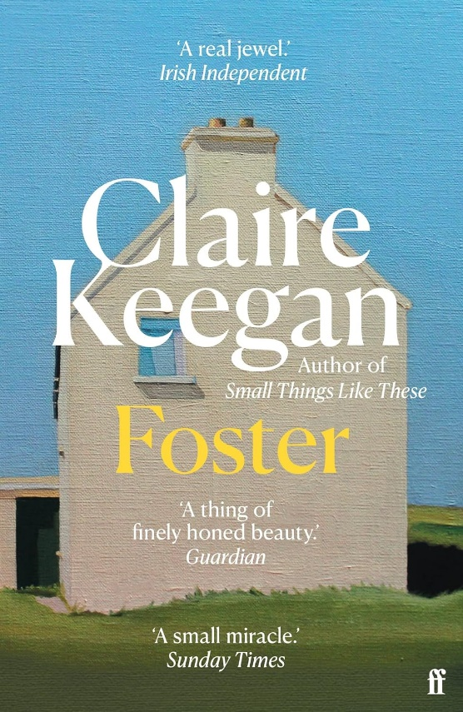

Foster
Claire Keegan
ISBN: 0571379141
Category: Fiction
Themes: Childhood, Loss, Love, Foster Parents, Home, Family, Kindness, Acceptance
Date Read: November 2023
Rating: ♥ ♥ ♥ ♥
My Book Notes:

I wonder why my father lies about the hay. He is given to lying about things that would be nice, if they were true.
*******

Now that my father has delivered me and eaten his fill, he is anxious for his tobacco; to have his smoke and get away. Always, it’s the same: he never stays in any place long after he’s eaten.
*******
This is a different type of house. Here there is room, and time to think. There may even be money to spare.
*******
I watch him reverse, turn into the lane, and drive away. I hear the wheels slam over the cattle grid, then the changing of gears and the noise of the motor going back the road we came. Why did he leave without so much as a good-bye, without even mentioning that he would come back for me?
*******
Her hands are like my mother’s hands but there is something else to them too, something I have never felt before and have no name for. I feel at such a loss for words, but this is a new place, and new words are needed.
*******
She turns me round to face her. I have not really looked into her eyes, until now. Her eyes are dark blue pebbled with other blues.
‘The are no secrets in this house, do you hear?
‘Where there is a secret,’ she says, ‘there’s shame – and shame is something we can do without.’
‘Okay.’ I take big breaths, so I won’t cry.
She puts her arm around me. ‘You’re just too young to understand.’

Walking back along the path and through the fields, holding her hand, I feel I have her balanced. Without me, I am certain she would tip over.
*******
I think of my sisters who will not yet be in bed. They will have thrown their clay burns against the gable wall of the outhouse, and when the rain comes, the clay will soften and turn to mud. Everything changes into something else, turns into some version of what it was before.
*******
She takes the clothes in off the line while they are still damp and sets up a board and starts ironing. She is like the man, doing it all without rushing but neither one of them ever really stops.
*******
I take off in a gallop to the end of the lane and find the post box and get the letters and race back. Kinsella is looking at his watch.
‘Not bad,’ he says, ‘for the first time.’
*******
The woman has been crying but she isn’t ashamed, ‘It’ll be nice for you to have some clothes of your own,’ she says then, wiping her eyes. ‘And Gorey is a nice town. I don’t know why I didn’t think of taking you there before now.’
*******
Kinsella reaches into his pocket and hands me something. ‘You’ll get a choc-ice out of that.’
I open my hand and stare at the pound note.
‘Couldn’t she buy half a dozen choc-ices out of that,’ the woman says.
‘Ah, what is she for, only for spoiling?’ Kinsella says.
*******
‘Isn’t your mammy’s birthday coming up shortly?’
‘Yes,’ I say, without being sure.
‘Well, pick out a card for her, so!’
She tells me to choose, and I pick a card with a frightened looking cat sitting in front of a bed of yellow dahlias.
*******
Walking down the road, there’s a taste of something darker in the air, of something that might fall and blow and change things.
*******
He pours red lemonade into a cup for me. I sit drinking it and eating the queen cakes out of the biscuit tin and looking at the dead man, hoping his eyes will open.
*******
Kinsella takes my hand in his. As soon as he takes it, I realise my father has never once held my hand, and some part of me wants Kinsella to let me go so I won’t have to feel this. It’s a hard feeling but as we walk along, I begin to settle and let the difference between my life at home and the one I have here be.
*******
Kinsella says a few meaningless things along the way then falls into the quiet way he has about him, and time passes without seeming to pass.

‘You don’t ever have to say anything,’ he says. ‘Always remember that as a thing you need never do. Many’s the man lost much just because he missed a perfect opportunity to say nothing.’
*******
‘See, there are three lights now where there was only two before.’
I look out across the sea. There, the two lights are blinking as before, but with another, steady light, shining in between.
‘Can you see it?’ he says.
‘I can,’ I say. ’It’s there.’
And that is when he puts his arms around me and gathers me into them as though I were his own.
*******
Now that I know I must go home, I almost want to go, to get it over with. I wake earlier than usual and look out at the wet fields, the dripping trees, the hills – which seem greener than they did when I came. I think back to this time, and it seems so long ago, when I used to wet the bed and worry about breaking things.
*******
We fold what clothes I have and place them inside, along with the books we bought at Webb’s in Gorey. Heidi, What Katy Did Next, The Snow Queen. At first, I struggled with some of the bigger words, but Kinsella kept his fingernail under each, patiently, until I guessed it or half-guessed it and then I did this by myself until I no longer needed to guess and read on. It was like learning to ride the bike; I felt myself taking off, the freedom of going places I couldn’t have gone before, and it was easy.
*******
My sisters look at me as though I’m an English cousin, coming over to touch my dress, the buckles on my shoes. They seem different, thinner, and nothing to say.

I take off from standing and race on down the lane. My heart does not so much feel that it is in my chest as in my hands, and that I am carrying to along swiftly, as though I have become the messenger for what is going on inside me.
*******
There is only one thing I care about now, and my feet are carrying me there.
*******

