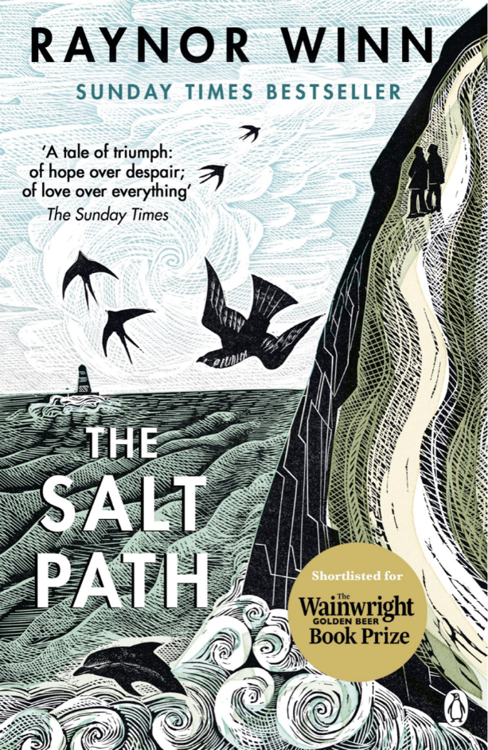

The Salt Path
Raynor Wynn
ISBN: 1405937181
Category: Biography, Personal Memoir, Travel
Themes: Walking, Nature, Homelessness, Wild Camping, Grief, Loss, Terminal Illness, Courage, Survival, Hope, Resilience, Endurance
Date Read: March 2022
Rating: ♥ ♥ ♥ ♥

My Book Notes:
Life had picked up every piece of ammunition possible and hurled it at him full force… He was exhausted with anger.
*******
Inside I was screaming, panicking, like a bee against a glass pane.
*******
‘the suffocating fog of shock’
*******
It came like a contraction. All-consuming and uncontrollable. I curled on the grass next to her and sobbed. Crying until my body stopped, spent, drained of tears, dried out by loss.
*******
I think I can feel homelessness now, like a balloon cut free in the wind. I’m scared.
*******
The truth: We’re homeless. We lost our home and we’ve nowhere to go, so just walking seemed a good idea.
*******
I gasped into the running water as I shed a layer of skin and sweat, bitterness, sadness, loss, fear. But only a layer.
*******
So lucky to have time.
*******
‘It’s the past that tells us who we are. Without it we lose our identity.’ Stephen Hawking
*******
‘Kernow’ – the local name for Cornwall
*******
It was a near physical struggle to put the sense of loss back in its box.
*******
Our story was born out of self-protection.
*******
The more times we repeated the lie, the less we felt the grief.
*******
Rather than the walk being a time to get our thoughts straight and make a plan, it had become a meditation, a mental void filled only with salt wind, dust and light. Each step had its own resonance, its moment of power or failure.
*******
Each day survived a reason to live through the next.
*******
Each lungful of salt scouring our memories, smoothing their edges, wearing them down.
*******
We were achieving something, even if we were old.
*******
Without money, we had moved into a world apart.
*******
I’m cut free from that connection (from the land and my status as a farmer’s daughter), from the meter of my existence, floating lost and uprooted. But I can still feel it.
*******
The wild was never something to fear or hide from. It was my safe place, the thing I ran to.
*******
All material things are slipping away, but in their wake a core of strength was beginning to re-form.
*******
The inescapable evidence of man’s need to take everything he can.
*******
A rhythm of pain and hunger mellowed into ache and thirst, softening eventually to just a booming rhythm.
*******
Life is now, this minute, it’s all we have. It’s all we need.
*******
Too far away now, our home had drifted out of range. It existed, but the distance made it untouchable. The raw, jagged, visceral pain of loss had gone, but the memory of it was still there.
*******
This ancient land was draining our strength and self-will, bending us to acceptance of the shaping elements.
*******
It’s touched you; it’s written all over you: you’ve felt the hand of nature. It won’t ever leave you now; you’re salted.
*******
Drawn to the edge, a strip of wilderness where we could be free to let the answers come, or not, to find a way of accepting life, our life, whatever that was.
*******
A new season had crept into me, a softer season of acceptance. Burnt in by the sun, driven in by the storms, I could feel the sky, the earth, the water, and revel in being part of the elements without a chasm of pain opening up at the thought of the loss of our place within it all. I was part of the whole.
*******
When I could no longer see them, would I remember them, and would just the memory be enough to fill me up and make me whole? Could anyone ever have enough memory?
*******
I was alone among friends. Homelessness had taught me that however much people think they want to help you, when you enter their home, you quickly become a cuckoo in their nest, a guest that outstays their welcome. Or their usefulness.
*******
I wasn’t living my life; I was just existing in someone else’s.
*******
‘Everybody needs beauty as well as bread.’ The Yosemite John Muir
*******
Rocks span the journey from salt to soil, catching life in motion, holding it still into eternity.
*******
Refugees from western civilization, cut adrift from life in a boat that rarely finds a harbour.
*******
The tent had ridden the storm, battered, bent, but not broken.
*******
Most people go through their whole lives without answering their own questions; What am I, what do I have within me? The big stuff. What a waste!
*******
We walked painfully slowly, stopping to look around every few minutes, excited to get to the end but willing it not to come.
*******
Our journey had drained us of every emotion, sapped our strength and our will. But then, like the windblown trees along our route, we had been re-formed by the elements into a new shape that could ride out whatever storms came over the bright new sea.
*******
Homelessness had left me stripped bare.
*******
Keep writing the story with hope.
*******

