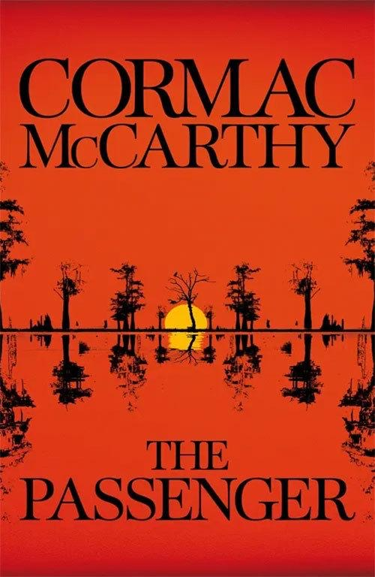

The Passenger

Cormac McCarthy
ISBN: 033053551X
Category: Fiction & Literature
Themes: Psychology, Mental Illness, Conspiracy, Grief, Suicide, Regret, Suffering, Friendship, Loneliness, Forgiveness, Memories, Social Isolation, Tragedy, Death, Faith, Morality
Date Read: February 2023
Rating: ♥ ♥ ♥

My Book Notes:

The legacy of the word is a fragile thing.
******
Forgiveness has a timeline.
******
Grief is the stuff of life. A life without grief is no life at all.
******
Regret is a prison. Some part of you which you deeply value lies forever impaled at a crossroads you can no longer find and never forget.
******
Without malefactors the world of the righteous is robbed of all meaning.
******
Mostly, I’m just in prayer mode about it.
******
Real trouble doesn’t begin in a society until boredom has become its most general feature. Boredom will drive even quiet minded people down paths they’d never imagined.
******
The horrors of the past lose their edge, and in the doing they bind us to a world careening toward a darkness beyond the bitterest speculation.
******
You have to believe that there is good in the world. You have to believe that the work of your hands will bring it into your life. If you don’t believe that you won’t have a life.
******
Beauty makes promises that beauty can’t keep.
******
I think people regret what they didn’t do more than what they did.
******
I believe in God’s design. I’ve had dark hours and I’ve had dark doubts in those hours. But that was never one of them.
******
Like most people he liked being consulted.
******
Life is brief.
******
For all his dedication there were times he thought the fine sweet edge of his grief was thinning.
******
When smart people do dumb things it’s usually due to one of two things. The two things are greed and fear. They want something they’re not supposed to have, or they’ve done something they weren’t supposed to do. In either case they’ve usually fastened on to a set of beliefs that are supportive of their state of mind but at odds with reality. It has become more important to them to believe than to know.
******
In the evenings he’d walk the beach and look out over the gray water where skeins of pelicans came labouring down the coast in their slow tandem flights above the offshore swells. Improbable birds.
******
Identity is everything.
******
The only thing worse than losing is not playing.
******
In the end you can escape everything but yourself.
******
Some people cling to wreckage forever.
******
How do I know what to trust?
******
Isn’t the purpose of pain to instruct?
******
The unbalanced enjoy a certain largesse of personal freedom increasingly abridged in a workaday world.
******
The world is full of people who should be more willing to weep.
******
You think that there are things which God will not permit.
******
A thing once seen cannot be unseen.
******
He pulled up the collar of his coat and watched the way the wind ransacked the grasses. Sudden furrows that ran and stopped. As if something unseen had bolted and lay crouching.
******
I am writing because there are things I don’t want to forget.
******
The world must be composed at least half of darkness.
******
She said one time that just because the world was spinning didn’t mean that you couldn’t get off.
******
When you have seen Jesus once you have seen him forever.
******
You don’t see any disjunct between what you know about the world and what you believe about God?
******
Jesus, the Israelite, heals. His truth is not going to come back to him void. It’s going to do what he wants it to do.
******
He tried to see her face, but he knew he was losing her.
******
The last light the nonbeliever will see will not be the dimming of the sun. It will be the dimming of God. Everyone is born with the faculty to see the miraculous. You have to choose not to. You think his patience is infinite? I think we’re probably almost there.
******
History is a collection of paper. A few fading recollections. After a while what is not written never happened.
******
If you think that the dignity of your life cannot be cancelled with the stroke of a pen, then I think you should think again.
******
There are certain dispensations for those who survive their own reviling.
******
Are you all right?
No. Are you?
No But we’re on reduced expectations. That helps.
******
The point is that the more that emotion is tied up in an incident the less likely is any narration of it going to be accurate.
******
Suffering is part of the human condition and must be borne. But misery is a choice.
******
A calamity can be erased by no amount of good. It can only be erased by a worse calamity.
******
Austerity lifts the heart and focuses the vision.
******
Travel light.
******
To prepare for any struggle is largely a work of unburdening oneself. If you carry your past into battle you are riding to your death.
******
It is the nature of people to imagine that the defeated must have done something to deserve their undoing.
******
To win a war or a revolution does not validate the cause.
******
A Godless life will not prepare one for a Godless death.
******
Mercy is the province of the person alone. There is mass hatred and there is mass grief. Mass vengeance and even mass suicide. But there is no mass forgiveness.
******
The daughters of men sit in half darkened closets inscribing messages upon their arms with razorblades and sleep is no part of their life.
******

