14th March 2023

Hi Family,

It is Adam’s birthday. If he were still with us, he would be 42. My reflections are designed to help us remember Adam and to guide our thoughts.

While walking along the Bendigo Creek Trail I was thinking about a quote I had read recently.

“For all his dedication there were times he thought the fine sweet edge of his grief was thinning.”

Obviously, the intensity of grief can’t be sustained. We would be a wreck otherwise. Our grief becomes more contained. There will always be unexpected moments that trigger an emotional response. Grief becomes our companion. We learn to live with grief, valuing its presence, as it gives us permission to remember, to acknowledge our loss.

The remembering is the challenge. That’s why it is important to take note. ‘If you don’t write it down you will forget.’

If you read my blog posts, you will notice that I reference Adam regularly. It is one way I can keep his memory alive and acknowledge how his life continues to shape my thinking.

The trauma of Adam’s death, and I’m talking about the trauma I experienced, has had a lasting impact. I feel a responsibility as a parent to speak for Adam, to honour him. I do so because he was a unique individual (it is our uniqueness that gives us our intrinsic value) and is not here to speak for himself.

Here are three memories of Adam that mean something to me.
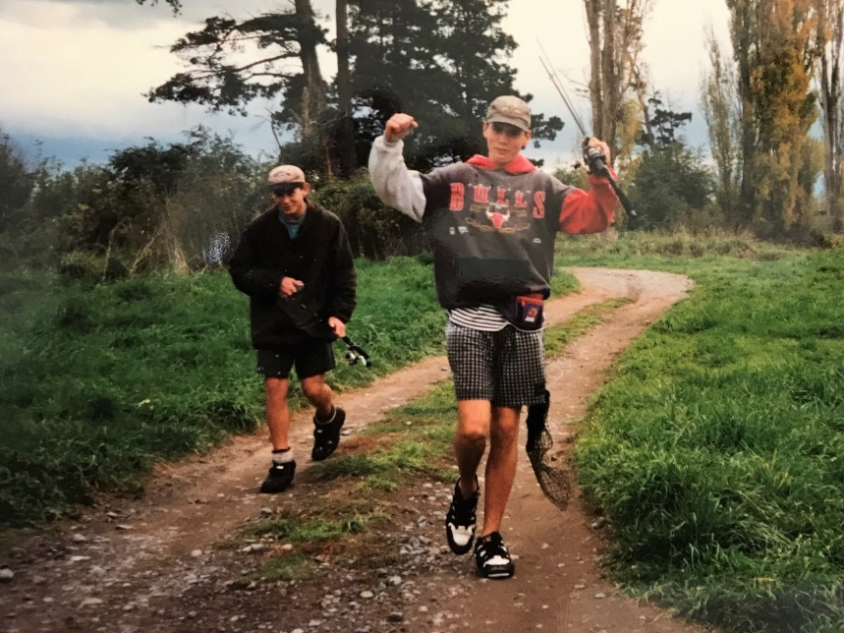

The first photo is of Adam returning from a day’s fishing. I love the joy that is evident on his face.

Adam loved fly fishing. But what was it that appealed to him? I can think of several things he would have enjoyed.

- The environment:
The Tukituki River is a magical place. Every bend in the river offers a new vista. The sights and sounds of nature that you exposed to refresh the spirit – the movement of the river as it shimmers over the shiny pebbles, the bird life around the water’s edge, the sound of the wind as it rustles the leaves, a dog barking on a distant rise, the cattle grazing in the field.

- The solitude:
Adam liked going fishing with his mates. But the actual fishing is a solitary exercise. Fishing for trout requires stealth. Any unnecessary noise will scare the fish. It helps to find a quiet spot where you will be undisturbed. The silence acts as a blanket, a calming presence, making you feel secure.

- The challenge:
Fly fishing is challenging. It requires knowledge (feeding habits, lures etc.), skill, concentration, patience, and determination. It is the sort of activity that you can lose yourself in. We need distractions, activities that allow a shift in focus rather than dwelling on ourselves.
If you travel to New Zealand in the future, plan a visit to the Tukituki River. Some of Adam’s ashes are spread there. As you stand on the bank of the river, appreciating the tranquil scene before you, cast your eyes upstream and you might see a lean figure wearing a cap and sunglasses, scanning the surface of the water, flicking his rod back and forth.

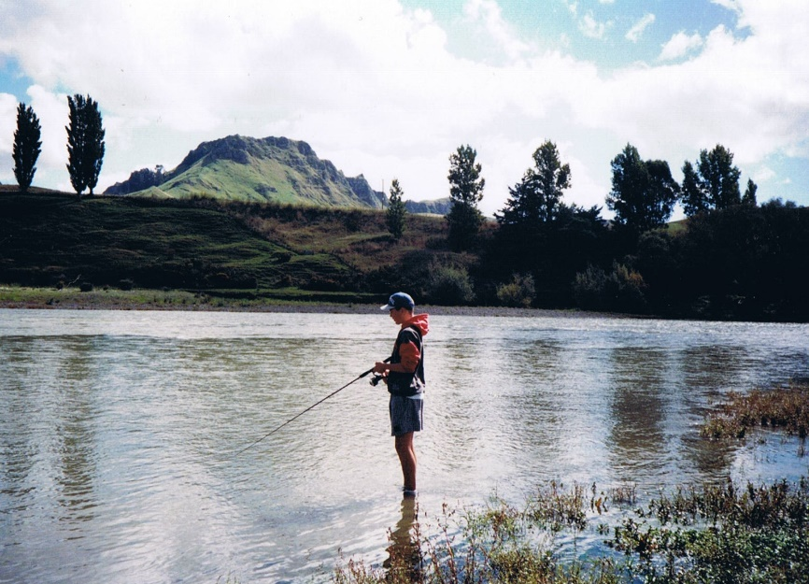

The second photo is of a trophy Adam was awarded for his bowling. Adam played cricket for the Tyabb 4th Eleven.

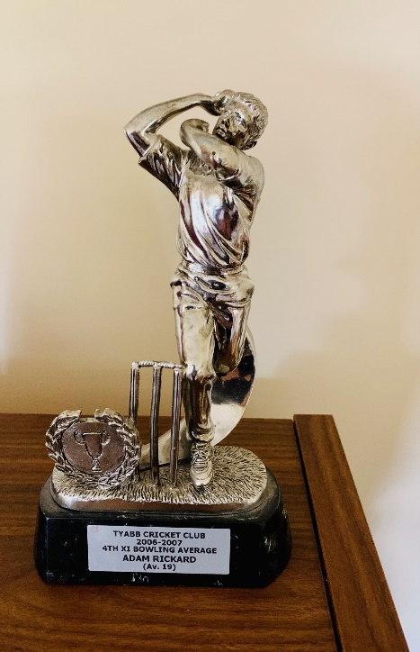

On a cold and overcast Saturday afternoon, Juliana and I went to watch him play at the Tyabb Cricket Ground in the centre of town. We parked the car by the fence that surrounds the oval. Adam noticed our arrival and gave a wave. He appeared subdued. Nervousness or awkwardness had a moderating effect on his behaviour. His interactions with the other players seemed cautious. We were fortunate to watch him bowl. He had a short run but bowled with good tempo. His strength was his consistency, his ability to bowl on a good length, keeping the batsmen on their guard.

I had a revelation the other day that Adam was Scotty Boland off a short run. So the next time you see Scotty Boland bowling for Australia, just think, ‘Adam Rickard – Scotty Boland off a short run.’

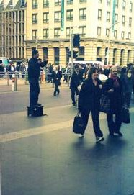

The third photo is of Adam preaching outside Southern Cross Station. I regard it an iconic photo as it captures ‘Preacher Boy’ in full flight.

I must confess I am somewhat ambivalent about street preaching. I am reminded of a guy in Hastings New Zealand who used to stand on the roundabout and preach at the cars as they went by. It seemed wacky to me.

I admire Adam’s courage, his willingness to share what had become a passion for him, God’s call on his life to preach the good news of Jesus. I can only imagine what he was saying. It would have had something to do with the ‘wrath of God.’ From my experience the language of street preachers creates unnecessary barriers. It seems counter productive to use a lot of religious jargon that is meaningless to most people. Having said that, there is an element of mystery that surrounds the preaching of God’s word. When God inhabits the words, anything is possible, miracles occur, people are changed, and God is honoured and praised.

I would encourage you to go and stand where Adam stood. The photo gives you a clue to the exact spot. Juliana and I have stood thereabouts. Indigenous people often talk about the land being sacred. This too is sacred ground, our sacred ground.

Happy birthday Adam. You are much loved. Our memories keep you alive in our hearts.

Love, Dad

